|  |
| --- |
| Stock Assessment Form  **Small Pelagics**  **Reference Year: 2016**  **Reporting Year: 2017** |
| [A brief abstract may be added here] |
|  |



Stock Assessment Form version 1.0 (January 2014)

Uploader: Please include your name

Stock assessment form

1. Basic Identification Data 3
2. Stock identification and biological information 5
   1. Stock unit 5
   2. Growth and maturity 6
3. Fisheries information 8
   1. Description of the fleet 8
   2. Historical trends 10
   3. Management regulations 11
   4. Reference points 12
4. Fisheries independent information 12
   1. MEDIAS ACUSTIC SURVEY 12
      1. Brief description of the chosen method and assumptions used 12
      2. Spatial distribution of the resources 16
      3. Historical trends 16
      4. Biological parameters and LFD 19
5. Ecological information 21
   1. Protected species potentially affected by the fisheries 21
   2. Environmental indexes 21
6. Stock Assessment 21
   1. SAM 21
      1. Model assumptions 21
      2. Scripts 22
      3. Input data and Parameters 23

Table 6.1.1. Catch numbers at age (in thousands) for the entire GSA17-18. 23

Table 6.1.2. Numbers at age (in thousands) for the acoustic survey in GSA 17 West + GSA 18 West-East. 23

Table 6.1.3. Numbers at age (in thousands) for the acoustic survey in GSA 17 East. 24

* + 1. Results 26

Table 6.1.4. Results of the final FLSAM assessment of anchovy in GSA17-18. 26

* + 1. Robustness analysis 30
    2. Retrospective analysis, comparison between model runs, sensitivity analysis, etc. 30
    3. Assessment quality 32

1. Stock Simulations 37
   1. Short term predictions 37
   2. Medium term predictions 37
   3. Long term predictions 37
2. Draft scientific advice 38
   1. Explanation of codes 39

# Basic Identification Data

|  |  |  |
| --- | --- | --- |
| **Scientific name:** | **Common name:** | **ISCAAP Group:** |
| *Engraulis encrasicolus* | Anchovy | [ISCAAP Group] |
| **1st Geographical sub-area:** | **2nd Geographical sub-area:** | **3rd Geographical sub-area:** |
| GSA17 | GSA18 |  |
| **4th Geographical sub-area:** | **5th Geographical sub-area:** | **6th Geographical sub-area:** |
|  |  |  |
| **1st Country** | **2nd Country** | **3rd Country** |
| Italy | Croatia | Slovenia |
| **4th Country** | **5th Country** | **6th Country** |
| Albania | Montenegro |  |
| **Stock assessment method: (direct, indirect, combined, none)** | | |
| **SAM** | | |
| **Authors:** | | |
| Angelini S.1, Arneri E.2, Belardinelli A.1, Biagiotti I.1, Bratina P.5, Canduci G.1, Colella S.1, Costantini I.1, Croci C.1, De Felice A.1, Domenichetti F.1, Donato F.1, Gašparević D.3, Juretic T.3, Leonori I.1, Martinelli M.1, Milone N.2, Modic T.5, Pallaoro A.3, Panfili M.1, Pesic A.4, Ikica Z.4, Santojanni A.1,Tesauro C.1, Ticina V.3 | | |
| **Affiliation:** | | |
| 1 CNR – ISMAR (National Research Council - Institute of Marine Science), Italy  2 FAO-AdriaMed, Rome, Italy  3 Institute of Oceanography and Fisheries, Croatia  4 Institute of Marine Biology, University of Montenegro, Kotor, Montenegro  5 Fisheries Research Institute of Slovenia | | |

The ISSCAAP code is assigned according to the FAO 'International Standard Statistical Classification for Aquatic Animals and Plants' (ISSCAAP) which divides commercial species into 50 groups on the basis of their taxonomic, ecological and economic characteristics. This can be provided by the GFCM secretariat if needed. A list of groups can be found here:

<http://www.fao.org/fishery/collection/asfis/en>

Indirect method (you can choose more than one):

* SAM

# Stock identification and biological information

## Stock unit

Many studies have been carried out regarding the presence of a unique stock or different sub-populations of anchovy in the Adriatic Sea (GSAs 17 and 18). This has several implications for the management, i.e. differences in the growth features between sub-populations imply the necessity of ad hoc strategies in the management. The hypothesis of two distinct populations claims the evidence of morphometric differences between northern and southern Adriatic anchovy, such as colour and length, and some variability in their genetic structure (Bembo et al., 1996). Nevertheless, many authors warn against the use of morphological data in studies on population structure (Tudela, 1999) and, a recent study from Magoulas et al. (2006), revealed the presence of two different clades in the Mediterranean, one of those is characterized by a high frequency in the Adriatic Sea (higher than 85%) with a low nucleotide diversity (around 1%). Also, outcomes of EU project STOCKMED indicated existence of one single stock of anchovy in GSA17 and western part of GSA18 (Fiorentino et al., 2014).

More recently Ruggeri et al. (2016) analysed genetic markers from anchovy samples from Adriatic Sea and Tyrrhenian Sea and didn’t find clear evidence of two distinct anchovy populations in these areas, even if in the northern Adriatic Sea geographic gradients in sea temperature, salinity and dissolved oxygen appear to drive adaptive differences in spawning time and early larval development among populations. Moreover, recent outcomes of EU project STOCKMED and EWG 17-02 indicated existence of one single stock of anchovy in the Adriatic Sea also. Therefore, also according to the fact that a lot of vessels registered in GSA 18 fish in GSA 17, it was decided to merge the two GSAs and thus carry out an assessment for anchovy in GSA 17-18. (Figure 2.1.1.).

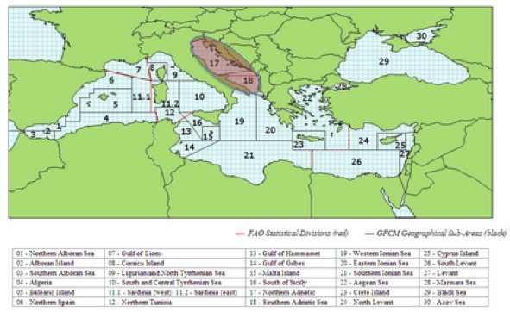

***Figure 2.1.1****: Geographical location of GSAs 17 and 18.*

## Growth and maturity

The growth parameters used for the estimation of natural mortality are the same already used in past assessments and are shown in Table 2.2.1 and 2.2.3.

Table 2.2.1: Maximum size, size at first maturity and size at recruitment.

|  |  |  |  |  |  |  |  |  |  |
| --- | --- | --- | --- | --- | --- | --- | --- | --- | --- |
| **Somatic magnitude measured**  **(LT, LC, etc)** | | |  | **Units** |  |  | | | |
| **Sex** | **Fem** | **Mal** | **Combined** | **Reproduction season** | **April-October** |  |  |  |  |
| **Maximum size observed** |  |  | 19 cm | **Recruitment season** |  |  | | | |
| **Size at first maturity** |  |  | 6-8 cm | **Spawning area** | Adriatic Sea, over continental shelf |  | | | |
| **Recruitment size to the fishery** |  |  | 7.5 cm | **Nursery area** | Adriatic Sea |  | | | |

Table 2.2.2: M vector and proportion of matures by size or age (Sex combined)

|  |  |  |
| --- | --- | --- |
| **Size/Age** | **Natural mortality** | **Proportion of matures** |
| *0* | *2.36* | *0.5* |
| *1* | *1.10* | *1* |
| *2* | *0.81* | *1* |
| *3* | *0.69* | *1* |
| 4+ | *0.625* | 1 |

The natural mortality value for age 4+ is the mean value between the natural mortality vale of age 4 and 5.

Table 2.2.3: Growth and length weight model parameters

|  |  |  |  |  |  |  |  |  |  |  |
| --- | --- | --- | --- | --- | --- | --- | --- | --- | --- | --- |
|  |  | |  |  |  | **Sex** | | | |  |
|  |  | | |  | **Units** | **female** | **male** | **Combined** | **Years** |  |
| **Growth model** | | **L∞** | | | cm |  |  | 19.4 |  |  |
| **K** | | | y-1 |  |  | 0.57 |  |  |
| **t0** | | | y |  |  | -0.5 |  |  |
| **Data source** | | | Sinovcic, 2000 | | | | |  |
| **Length weight** **relationship** | | **a** | | |  |  |  | 0.0032 |  |  |
| **b** | | |  |  |  | 3.2339 |  |  |
|  |  | **M**  (scalar) | | |  |  |  |  |  | |
|  |  | **sex ratio** (% females/total) | | |  |  |  |  |  | |

# 3. Fisheries information

## 3.1 Description of the fleet

Anchovy are fished by purse seiners and pelagic trawlers belonging to Italy, Croatia and, to a much smaller extent, Slovenia, Albania and Montenegro.

The Italian fleet is composed of about 65 pairs of mid-water trawlers and about 20 purse seiners (with quite different tonnage), with the former being predominant on the latter ones. Most of the Italian boats whose port of registry is located in GSA 18 actually fish and land in GSA 17. Croatia has about 270 active purse seiners targeting small pelagics (mainly sardine) while in Slovenia only 3 purse seiners are currently active.

In Montenegro most of the catches are originated from small-scale beach seine fisheries and from small purse seiners fisheries in coastal waters (< 70 m depth).

Exploitation is based on all the age classes from 0 to 4+.

The Italian catches of anchovy represent the majority of the catches, while the Croatian small pelagic fishery concentrates mainly on sardine.

Table 3.1.1: Description of operational units exploiting the stock in 2016

|  |  |  |  |  |  |  |  |
| --- | --- | --- | --- | --- | --- | --- | --- |
|  |  | **Country** | **GSA** | **Fleet Segment** | **Fishing Gear Class** | **Group of Target Species** | **Species** |
|  |  |
| **ITA_PTM_1718** | | Italy | GSA17-18 | PTM_0640 | Pelagic Trawler | Small pelagic | *E. encrasicolus*  *S. pilchardus*  *Mugilidae* spp. |
| **ITA_PS_1718** | | Italy | GSA17-18 | PS_0640 | Purse seiners | Small pelagic | *E. encrasicolus*  *S. pilchardus*  *Mugilidae* spp. |
| **HRV_PS_17** | | Croatia | GSA17 | PS_0640 | Purse seiners | Small pelagic | *E. encrasicolus*  *S. pilchardus* |
| **SLO_PS_17** | | Slovenia | GSA17 | PS_1218 | Purse seiners | Small pelagic | *E. encrasicolus*  *S. pilchardus* |
| **ALB_18** | | Albania | GSA18 |  | Purse seiners | Small pelagic | *E. encrasicolus*  *S. pilchardus* |
| **MNE_18** | | Montenegro | GSA18 | PS_0624 | Purse seiners | Small pelagic | *E. encrasicolus*  *S. pilchardus* |

Table 3.1.2: Catch, bycatch, discards and effort by operational unit in the reference year (2016)

|  |  |  |  |  |  |  |
| --- | --- | --- | --- | --- | --- | --- |
| **Operational Units\*** | **Fleet**  **(n° of boats)\*** | **Catch (T or kg of the species assessed)** | **Other species caught (names and weight )** | **Discards** **(species assessed)** | **Discards** **(other species caught)** | **Effort (units)** |
| ITA_PTM_1718 | 135* | 25,666 |  | < 1% |  |  |
| ITA_PS_1718 | 23* |  | < 1% |  |  |
| HRV_PS_17 | 279* | 8,228 |  | < 1% |  |  |
| SLO_PS_17 | 3* | 5.5 |  | < 1% |  |  |
| ALB_PS_18 |  | 280 |  | < 1% |  |  |
| MNE_PS_18 |  | 72.5 |  | < 1% |  |  |
| **Total** |  | 34,252 |  |  |  |  |

*source: DCF effort data 2016

## 3.2 Historical trends

In figure 3.2.1 the trend in landings from 1975 to 2016 for the Eastern Adriatic (Croatia, Slovenia, Albania and Montenegro) and the western Adriatic (Italy GSA17-18) are shown. Slovenian, Albania and Montenegrin catches are on the overall low (around 320 tonnes in 2015). For Albania and Montenegro landings were assumed as a fixed percentage of Croatian catches before, respectively, 2012 and 2007.

The catch of anchovy reached a maximum in the eighties, whose main contribution was from the Italian fleet; in 1986-1987 the catch collapsed to the historical minimum, and then started to increase again reaching a new peak in 2007. The Croatian share started increasing in 2000 and rose constantly until 2011 (~15,000 tonnes); in 2012 dropped to lower levels (less than 10,000 tonnes) to increase again in 2015. The overall catch of anchovy for 2016 is 34,252 tonnes and shows increase compared to average of period 2013-2015 (32,955 tonnes), but a slight decrease compared to 2015 catches (39,737 tonnes).

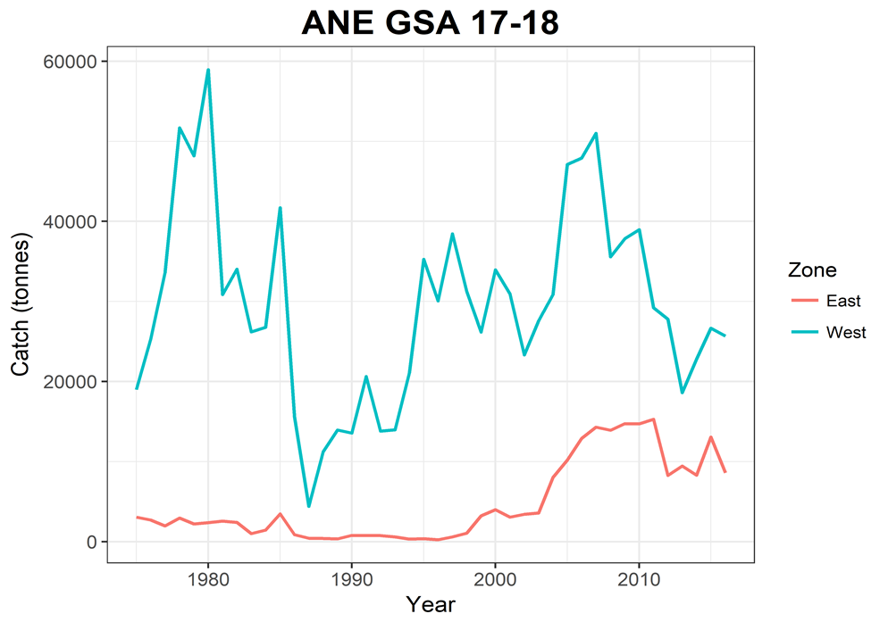

*Figure 3.2.1: Adriatic catches for the whole period assessed (1975-2016) for the Eastern and Western side of GSA17-18.*

In figure 3.2.2 the trend in the cohorts of the total catches is shown. Age 1 is the fully recruited age in great part of the time series.

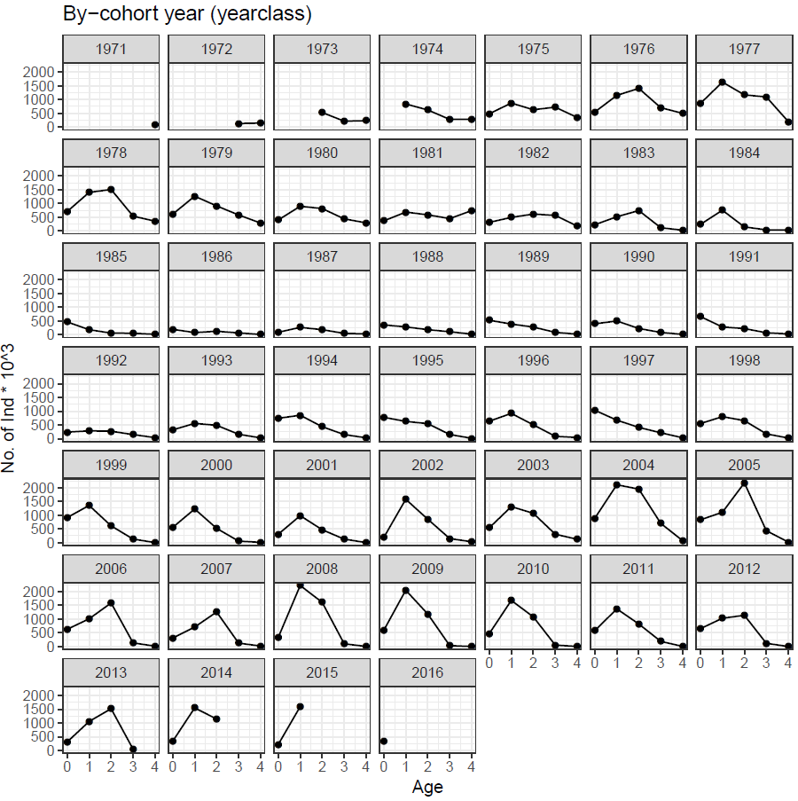

*Figure 3.2.2: Catch-at-age cohort plots for GSA 17-18 anchovy.*

## 3.3 Management regulations

A multi–annual management plan for small pelagic fisheries in the Adriatic Sea has been established by the General Fisheries Commission for the Mediterranean in 2012 (GFCM/37/2013/1). In particular, the plan establishes “a temporal closure period of no less than 15 continuous days for each vessels fishing small pelagic stocks in GSA 17 in order to protect nursery and spawning areas. This closure shall be designated in waters under the jurisdiction and shall take place between 1 April and 31 August” (GFCM/38/2014/1). Moreover, for year 2015 it was decided that “each fishing vessel targeting anchovy shall not exceed 144 fishing days per year” (GFCM/38/2014/1). In addition, in 2016 the GFCM Recommendation (REC.CM-GFCM/40/2016/3) established further emergency measures for the small pelagic stocks in the Adriatic Sea. In particular, the plan establishes “a temporal closure period of no less than 15 continuous days and up to 30 continuous days for sardine from the 1st of October to 31st of March, and for anchovy from the 1st of April to the 30th of September. Also, additional closures for vessels over 12 m length overall for no less than 6 months, which shall cover at least 30 percent of the area which has been identified as nursery area or area important for the protection of early age classes of fish (in territorial and inner sea), are expected.

Regarding the closure period, Italy has been enforcing for years a general regulation concerning the fishing gears and since 1988 a suspension (about 42 days) of fishing activity of pelagic trawlers and purse seiners has implemented in summer.

In Croatia from 2013 management plan for purse seiners “srdelara” has been endorsed. A closure period is observed from the 1st December to the 31st January (except period 14th-24th December) and 1st-31st of May from the Croatian purse seiners. In 2011 and 2012 the closure season for the Italian fleet was extended to 60 days (August and September). Also, additional spatial closure for vessels over 12 m length overall has been applyed in Croatian inner sea (GSA17-East) since 2015, which is bealived to be nursery area and/or area important for the protection of early age classes.

In Montenegro a closure period of 15 days was observed from the first to the 15th of April, whereas in Slovenia from 17th of March to 15th of April.

## Reference points

Table 3.3-1: List of reference points and empirical reference values previously agreed (if any)

|  |  |  |  |  |  |
| --- | --- | --- | --- | --- | --- |
| **Indicator** | **Limit Reference point/empirical reference value** | **Value** | **Target Reference point/empirical reference value** | **Value** | **Comments** |
| **B** |  |  |  |  |  |
| **SSB** | Blim | 45,936 | Bpa | 91,872 | 2015 GFCM benchmark assessment |
| **F** |  |  | Fmsy | 0.554 | 2015 GFCM benchmark assessment |
| **Y** |  |  |  |  |  |
| **CPUE** |  |  |  |  |  |
| **Index of Biomass at sea** |  |  |  |  |  |

# Fisheries independent information

## MEDIAS ACOUSTIC SURVEY

### Brief description of the chosen method and assumptions used

Italian acoustic survey was carried out since 1976 in the Northern Adriatic Sea (half of the western area) and since 1987 also in the Mid and southern Adriatic Sea (the other half of the western area). Since 2007 even Slovenia was included in the western acoustic survey estimations. Since 2009 the MEDIAS (MEDIterranean Acoustic Surveys) project entered in the EC Data Collection framework since 2009.

Since 2008, and with exception of 2009, the Eastern GSA 18 (Montenegro and Albania waters) was monitored by Italian acoustic survey group in collaboration with local Institutes.

The eastern part of GSA 17 (except Slovenia) was covered by Croatian national pelagic monitoring program (i.e. acoustic survey) PELMON since 2004. Since 2013 this acoustic survey has been carried out within EU MEDIAS framework.

Estimates from acoustic surveys were included in the assessment model considering three tuning indexes:

1. The data from the surveys in GSA 17 West and GSA 18 in the form of numbers-at-age from 2004 to 2016;
2. Acoustic survey East, that includes the eastern side of GSA 17 in the form of numbers-at-age from 2013 to 2016;
3. Acoustic survey East biomass, that includes the eastern side of GSA 17 in the form of total biomass from 2003 to 2012.

The surveys results have been aggregated as follows:

* Western GSA 17 + Western GSA 18 + Eastern GSA 18;
* Eastern GSA 17.

Due to the different time series available for the Western and Eastern GSA 18 (GSA18 East started in 2008) an average proportion over the years was calculated to estimate the biomass in the Eastern GSA 18 for the years 2004-2007 (~2% of total GSA17-18 west).

When length frequency distributions were missing, the length structure was assumed equal to the one in the following year.

Abundance indices at age for the West and East acoustic surveys were updated applying new age length keys. The abundance at age for the West acoustic survey was estimated using the ALK 2016, derived from the new criteria of otolith reading preliminary agreed during the AdriaMed Study Group on intercalibration of anchovy otolith reading. The abundance at age for the East Echosurvey was determined following the ICES WKARA2 age-reading protocol, and ALK is determined for every year separately.

The standardized methodology followed during MEDIAS surveys are given in the MEDIAS handbook (MEDIAS, April 2016) revised annually (MEDIAS Steering Committee report, 2016).

**Direct methods: acoustics**

1. **GSA 17 WEST + GSA 18 WEST-EAST**

Table 4.1.1.1: Acoustic cruise information.

|  |  |  |  |  |
| --- | --- | --- | --- | --- |
| **Date** | From the 21st of May to the 27th of June 2016 (North and South Adriatic: Italy, Slovenia, Montenegro and Albania) | | | |
| **Cruise** | MEDIAS Adriatic GSA 17 and GSA 18 | | **R/V** | Dallaporta |
| **Target species** | | Anchovy, Sardine | | |
| **Sampling strategy** | | Parallel grid of transects perpendicular to the coastline | | |
| **Sampling season** | | Summer | | |
| **Investigated depth range (m)** | | 10-200 m | | |
| **Echo-sounder** | | Simrad EK60 | | |
| **Fish sampler** | | Pelagic trawl | | |
| **Cod –end mesh size as opening (mm)** | | 18 | | |
| **ESDU (i.e. 1 nautical mile)** | | 1 nautical mile | | |
| **TS (Target Strength)/species** | | Anchovy b20: -74.6; Sardine b20: -72.5 | | |
| **Software used in the post-processing** | | Echoview | | |
| **Samples (gear used)** | | Samples of anchovy, sardine and other pelagic species (secondary in occurrence) caught by means of pelagic trawl | | |
| **Biological data obtained** | | Anchovy and sardine numerical abundance and biomass by nautical mile and by total area; anchovy and sardine spatial distribution in numbers and biomass | | |
| **Age slicing method** | | Age-length key by otolith reading | | |
| **Maturity ogive used** | | Macroscopic gonad identification | | |

Table 4.1.1.2: Abundance at age from acoustic survey for the years 2004-2016.

|  |  |  |  |  |  |
| --- | --- | --- | --- | --- | --- |
| **Year** | **Age 0** | **Age 1** | **Age 2** | **Age 3** | **Age 4** |
| **2004** | 35560685 | 18764020 | 613692 | 5645 | 2540 |
| **2005** | 40787857 | 10033202 | 134557 | 4072 | 1832 |
| **2006** | 76696622 | 26700888 | 3988381 | 151803 | 61547 |
| **2007** | 73618538 | 28091728 | 2747682 | 70127 | 25026 |
| **2008** | 64356278 | 44561926 | 1557486 | 64161 | 13156 |
| **2009** | 73769477 | 21903651 | 429701 | 16421 | 17861 |
| **2010** | 45236308 | 26066281 | 566016 | 21460 | 23342 |
| **2011** | 49485704 | 23424898 | 305350 | 17105 | 13498 |
| **2012** | 86799211 | 18037774 | 62577 | 6364 | 6915 |
| **2013** | 43260113 | 18805485 | 480456 | 946 | 158 |
| **2014** | 28448153 | 18667773 | 273617 | 133 | 0 |
| **2015** | 18400911 | 14596893 | 621395 | 47936 | 22799 |
| **2016** | 11384028 | 4493347 | 21872 | 0 | 0 |

### Spatial distribution of the resources

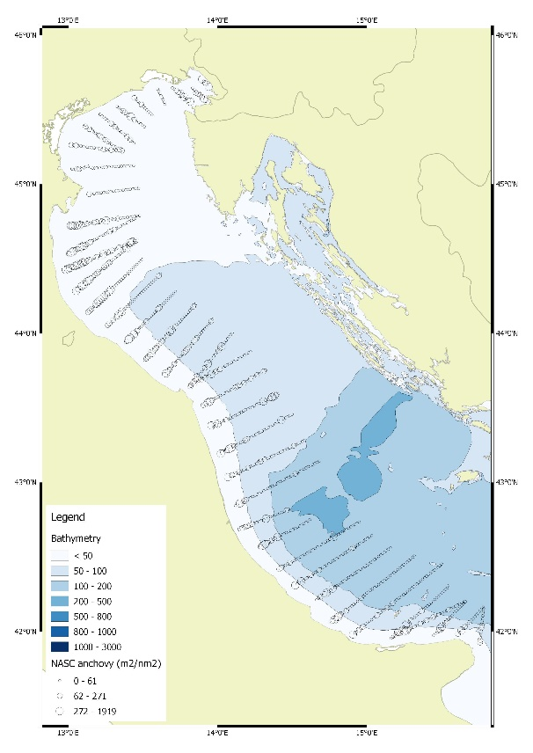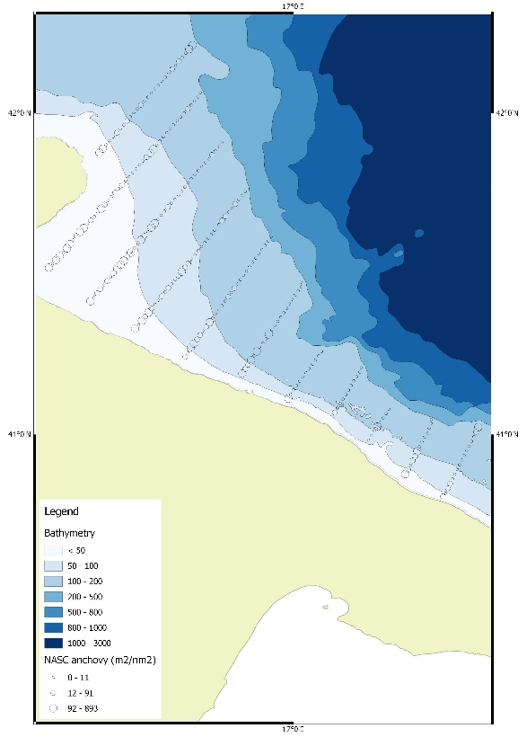

Figure 4.1.2.1. NASC Anchovy for GSA17 and GSA 18 West acoustic survey 2016.

### Historical trends

**GSA 17 WEST + GSA 18 WEST-EAST**

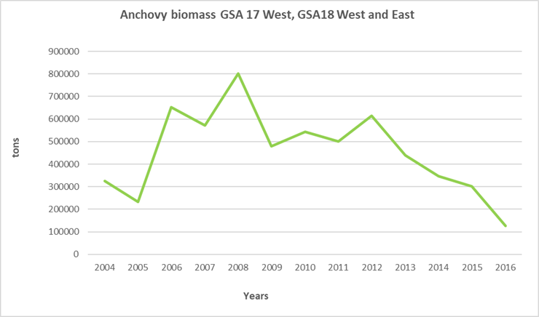

Figure 4.1.3.1. Biomass (tonnes) of anchovy in the Western GSA 17 and Western and Eastern GSA 18 from acoustic surveys carried out from 2004 to 2016

### Anchovy LFD from 2004 to 2016 for GSA 17 West, GSA18 West and East

In the plot below the length frequency distributions observed in the acoustic survey for the three areas (GSA17 West, GSA18 East and GSA18 West) from 2004 to 2016 are shown (Figure 4.1.4.1).

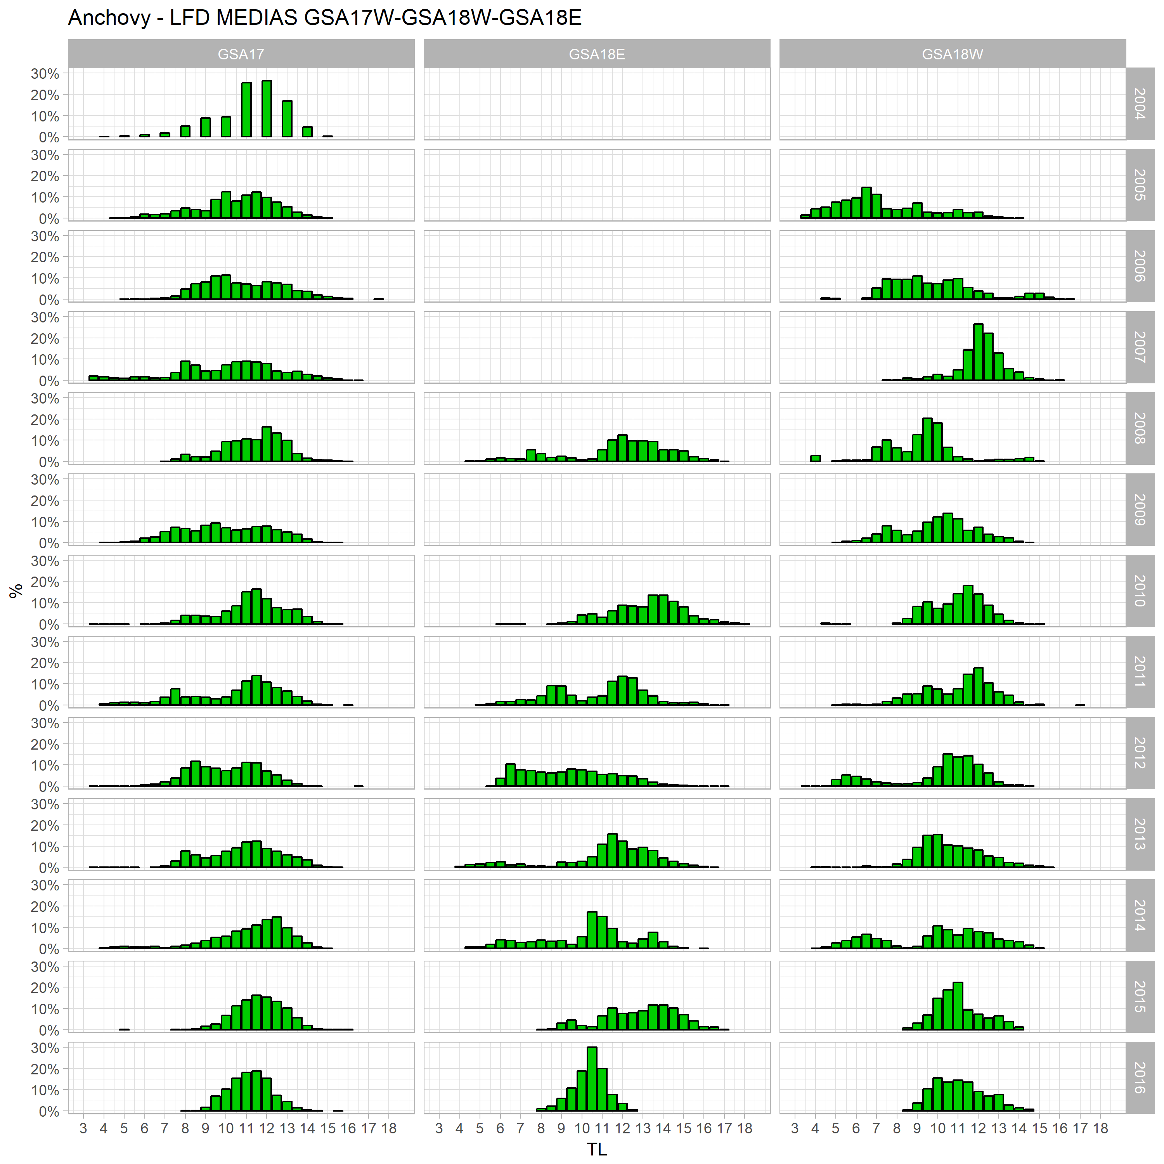

*Figure 4.1.4.1. LFD observed in the acoustic survey for GSA 17 West, GSA 18 West and GSA 18 East from 2004 to 2016.*

**II. GSA 17 EAST**

Table 4.1.1.4: Acoustic cruise information.

|  |  |  |  |  |
| --- | --- | --- | --- | --- |
| **Date** | 24 August – 22 September 2016 | | | |
| **Cruise** | MEDIAS GSA 17 EAST | | **R/V** | BIOS DVA |
| **Target species** | | Anchovy, Sardine | | |
| **Sampling strategy** | | Partially random; parallel transects in open sea and transects adapted to geomorphology in inner sea | | |
| **Sampling season** | | September | | |
| **Investigated depth range (m)** | | 7 - 200 | | |
| **Echo-sounder** | | SIMRAD EK60 (38 kHz) | | |
| **Fish sampler** | | Pelagic trawl net | | |
| **Cod –end mesh size as opening (mm)** | | 18 mm (with cod-end cover as used in sardine fry fishery - 4 mm) | | |
| **ESDU (i.e. 1 nautical mile)** | | 1 nm | | |
| **TS (Target Strength)/species** | | Anchovy b20: -74.6 | | |
| **Software used in the post-processing** | | Echoview | | |
| **Samples (gear used)** | | Samples of anchovy, sardine and other pelagic species (secondary in occurrence) caught by means of pelagic trawl | | |
| **Biological data obtained** | | Anchovy and sardine numerical abundance and biomass by nautical mile and by total area; anchovy and sardine spatial distribution in numbers and biomass | | |
| **Age slicing method** | | Age-length key by otolith reading | | |
| **Maturity ogive used** | | Macroscopic gonad identification | | |

### Biological parameters and LFD

The table below (Table 4.1.5.1) shows the number at age for the acoustic survey for the eastern GSA17 area from 2013-2016. Age reading is performed based on ICES WKARA2 age-reading protocol, and ALK is determined for every year separately.

Table 4.1.5.1: Abundance at age from acoustic survey for the years 2013-2016.

|  |  |  |  |
| --- | --- | --- | --- |
| **Year** | **Age 0** | **Age 1** | **Age 2** |
| **2013** | 2477404 | 2384276 | 1846 |
| **2014** | 8202814 | 1417362 | 1531 |
| **2015** | 3024067 | 1585048 | 1875 |
| **2016** | 3410073 | 1220159 | 15772 |

**Spatial distribution of the resources**

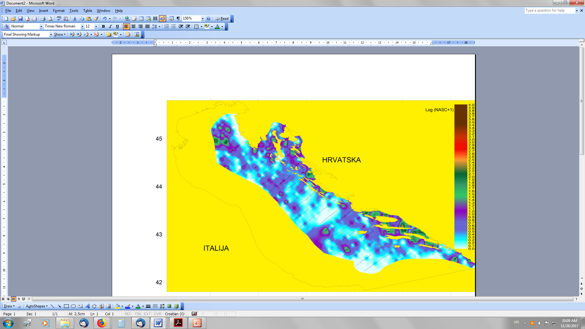

Figure 4.1.4.2. Spatial distribution of anchovy in the eastern part of GSA17 (September, 2016).

**Historical trends**

Figure 4.1.4.2 shows the biomass trend for the East Echosurvey carried out as Croatian national monitoring programme PELMON.

This year, the stock assessment model includes also the biomass estimates of this survey from years 2003 to 2012. It was chosen to include this third index because the biomass information are the only valid information available coming from this survey for these years. However, in 2011 and 2012 the echosuvey was not carried out for the entire area, thus the total estimates are estimated.

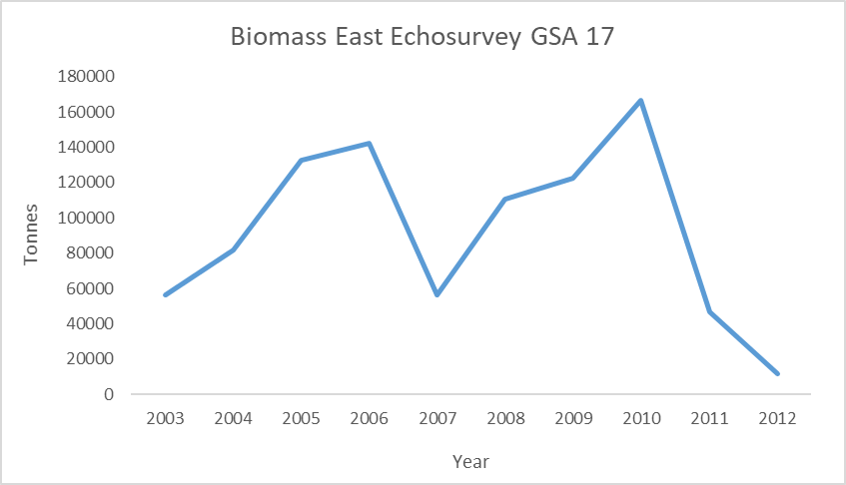

Figure 4.1.4.3. Biomass (tonnes) of anchovy in the Eastern side of GSA 17 estimated by the acoustic surveys carried out from years 2003 to 2012 as used in assessment for tuning purpose.

**Anchovy LFD from 2013 to 2016 for East Echosurvey GSA 17**

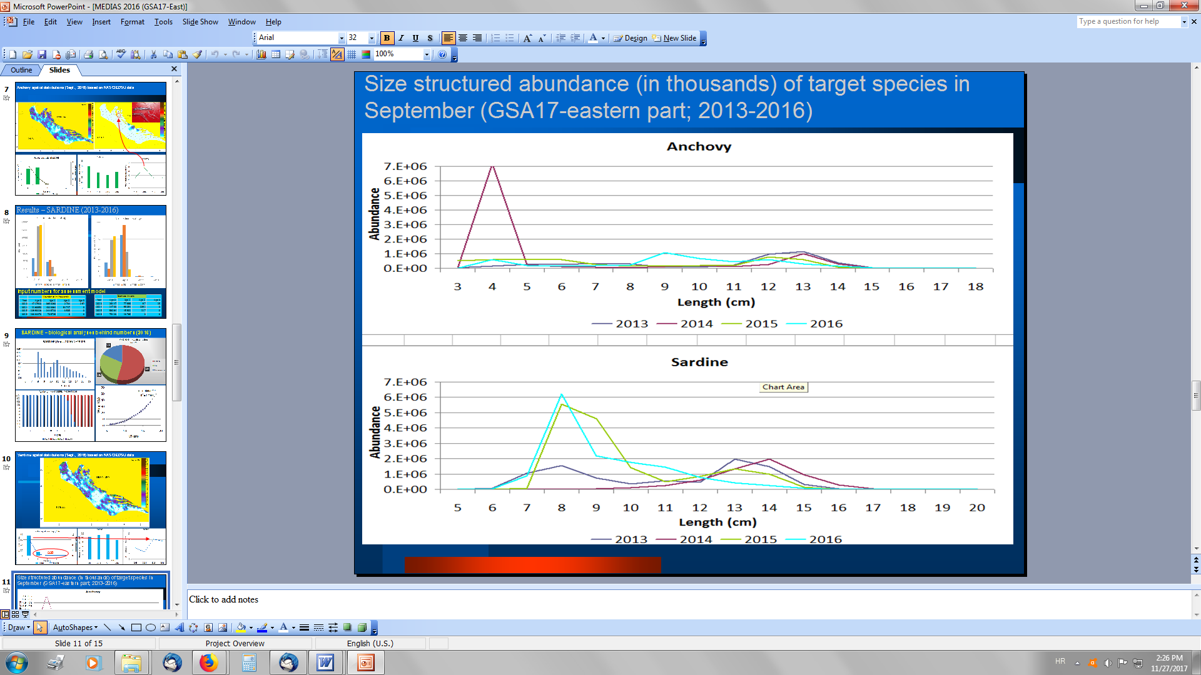

Figure 4.1.4.4. Anchovy LFD from MEDIAS 2013-2016 carried out in the eastern part of GSA17.

# Ecological information

## Protected species potentially affected by the fisheries

N/A

## 5.2 Environmental indexes

N/A

# 6. Stock Assessment

## 6.1 SAM

### 6.1.1 Model assumptions

State-Space Assessment Program (SAM) has been performed to assess the stock status of anchovy in GSA 17 from 1975 to 2016.

Acoustic surveys data were available and used as tuning indices from 2004 to 2016.

The SAM environment is encapsulated into the Fisheries Library in R (FLR) (Kell *et al*., 2007) in the form of the package “FLSAM”. The state-space assessment model (SAM) is an assessment model which is used for several assessments within ICES. The model allows selectivity to evolve gradually over time. It has fewer model parameters than full parametric statistical assessment models, with quantities such as recruitment and fishing mortality modelled as random effects. MEDIAS estimates were included in the assessment model considering three tuning indexes:

1. Acoustic survey West that includes the western side of GSA 17 and the entire GSA 18 in the form of numbers-at-age from 2004 to 2016, with data based on a preliminary agreement and the discussion inside AdriaMed Study Group on intercalibration of anchovy otolith reading and taking into account the ICES WKARA2 2016 Report;
2. Acoustic survey East, that includes the eastern side of GSA 17 in the form of numbers-at-age from 2013 to 2016, with data based on ICES WKARA2 age-reading protocol;
3. Acoustic survey East biomass that includes the eastern side of GSA 17 in the form of total biomass from 2003 to 2012.

All assessments are performed with version 0.99-3 of FLSAM, together with version 2.5 of the FLR library (FLCore).

### 6.1.2 Scripts

The control file with the final settings is shown below:

#####################

[1] "Final Assessment"

Slot "range":

min max plusgroup minyear maxyear minfbar maxfbar

0 4 4 1975 2016 1 2

Slot "fleets":

catch Echo West Echo East Echo East Biomass

0 2 2 3

Slot "states":

age

0 1 2 3 4

catch 1 2 3 4 5

Slot "logN.vars":

0 1 2 3 4

1 2 3 3 4

Slot "catchabilities":

age

0 1 2 3 4

EchoWest1718 1 2 3 4 4

EchoEast 5 6 7 NA NA

Slot "f.vars":

age

0 1 2 3 4

catch 1 1 2 2 2

Slot "obs.vars":

age

fleet 0 1 2 3 4

catch 1 2 3 4 4

EchoWest1718 5 6 7 7 8

EchoEast 9 10 11 NA NA

###################

### 6.1.3 Input data and Parameters

The catch and indices numbers at age used in the assessment are reported in tables from 6.1.3.1 to 6.1.3.3.

### *Table 6.1.3.1. Catch numbers at age (in thousands) for the entire GSA17-18.*

|  |  |  |  |  |  |  |  |  |  |  |
| --- | --- | --- | --- | --- | --- | --- | --- | --- | --- | --- |
| **Catch numbers at age (thousands)** | | | | | |  |  |  |  |  |
| **Age** | **1975** | **1976** | **1977** | **1978** | **1979** | **1980** | **1981** | **1982** | **1983** | **1984** |
| **0** | 482092 | 546700 | 855182 | 703778 | 608478 | 396695 | 363550 | 311340 | 226546 | 235759 |
| **1** | 838593 | 871860 | 1151096 | 1635116 | 1401892 | 1263525 | 897099 | 684511 | 491870 | 515742 |
| **2** | 526958 | 620105 | 628420 | 1405033 | 1169253 | 1507232 | 909873 | 813774 | 585420 | 612714 |
| **3** | 126873 | 212748 | 276774 | 721213 | 701390 | 1093211 | 536268 | 580203 | 437479 | 448569 |
| **4** | 67692 | 143470 | 230727 | 276345 | 346055 | 496358 | 195789 | 354486 | 285655 | 293053 |
| **Age** | **1985** | **1986** | **1987** | **1988** | **1989** | **1990** | **1991** | **1992** | **1993** | **1994** |
| **0** | 469534 | 199939 | 91551 | 360736 | 529317 | 399513 | 664502 | 239126 | 321326 | 743359 |
| **1** | 752725 | 186764 | 80929 | 271133 | 287824 | 391977 | 503464 | 285232 | 285794 | 557188 |
| **2** | 739741 | 144217 | 62344 | 129518 | 185917 | 187817 | 281725 | 229990 | 227184 | 272533 |
| **3** | 564111 | 115497 | 39121 | 56632 | 69425 | 53015 | 111255 | 89614 | 86514 | 74472 |
| **4** | 739260 | 175410 | 25316 | 31938 | 18800 | 13257 | 33338 | 25370 | 23056 | 15473 |
| **Age** | **1995** | **1996** | **1997** | **1998** | **1999** | **2000** | **2001** | **2002** | **2003** | **2004** |
| **0** | 779560 | 637643 | 1033852 | 550646 | 910877 | 551555 | 303874 | 185243 | 540595 | 889913 |
| **1** | 854068 | 629839 | 921285 | 675040 | 802753 | 1352876 | 1223921 | 980195 | 1576735 | 1310272 |
| **2** | 488011 | 436178 | 547882 | 505319 | 411223 | 658685 | 610490 | 517524 | 468440 | 852746 |
| **3** | 149939 | 160960 | 150329 | 152831 | 88520 | 215994 | 176276 | 128525 | 54943 | 126502 |
| **4** | 32304 | 39182 | 30795 | 32790 | 15399 | 42218 | 32814 | 24269 | 1473 | 9896 |
| **Age** | **2005** | **2006** | **2007** | **2008** | **2009** | **2010** | **2011** | **2012** | **2013** | **2014** |
| **0** | 828627 | 625804 | 306937 | 328454 | 588808 | 470353 | 578464 | 648892 | 306895 | 332484 |
| **1** | 2105130 | 1104045 | 1008445 | 708483 | 2220233 | 2048993 | 1678148 | 1369598 | 1029190 | 1053303 |
| **2** | 1067552 | 1945985 | 2172848 | 1584265 | 1255758 | 1606682 | 1183670 | 1079939 | 819622 | 1136174 |
| **3** | 147358 | 305944 | 698241 | 432828 | 130538 | 121756 | 98578 | 32647 | 51239 | 186128 |
| **4** | 1814 | 30817 | 121239 | 67849 | 19687 | 15213 | 19466 | 4065 | 1570 | 3169 |
| **Age** | **2015** | **2016** |  |  |  |  |  |  |  |  |
| **0** | 215147 | 332131 |  |  |  |  |  |  |  |  |
| **1** | 1547601 | 1594711 |  |  |  |  |  |  |  |  |
| **2** | 1517949 | 1142627 |  |  |  |  |  |  |  |  |
| **3** | 116784 | 45008 |  |  |  |  |  |  |  |  |
| **4** | 3219 | 478 |  |  |  |  |  |  |  |  |

### *Table 6.1.3.2. Numbers at age (in thousands) for the acoustic survey in GSA 17 West + GSA 18 West-East.*

|  |  |  |  |  |  |  |
| --- | --- | --- | --- | --- | --- | --- |
| **Numbers at age (thousands) - Acoustic Survey GSA 17 WEST + GSA 18 WEST-EAST** | | | | | | |
| **Age** | **2004** | **2005** | **2006** | **2007** | **2008** | **2009** |
| **0** | 35560685 | 40787857 | 76696622 | 73618538 | 64356278 | 73769477 |
| **1** | 18764020 | 10033202 | 26700888 | 28091728 | 44561926 | 21903651 |
| **2** | 613692 | 134557 | 3988381 | 2747682 | 1557486 | 429701 |
| **3** | 5645 | 4072 | 151803 | 70127 | 64161 | 16421 |
| **4** | 2540 | 1832 | 61547 | 25026 | 13156 | 17861 |
|  |  |  |  |  |  |  |
| **Age** | **2010** | **2011** | **2012** | **2013** | **2014** | **2015** |
| **0** | 45236308 | 49485704 | 86799211 | 43260113 | 28448153 | 18400911 |
| **1** | 26066281 | 23424898 | 18037774 | 18805485 | 18667773 | 14596893 |
| **2** | 566016 | 305350 | 62577 | 480456 | 273617 | 621395 |
| **3** | 21460 | 17105 | 6364 | 946 | 133 | 47936 |
| **4** | 23342 | 13498 | 6915 | 158 | 65 | 22799 |
|  |  |  |  |  |  |  |
| **Age** | **2016** |  |  |  |  |  |
| **0** | 11384028 |  |  |  |  |  |
| **1** | 4493347 |  |  |  |  |  |
| **2** | 21872 |  |  |  |  |  |
| **3** | 65 |  |  |  |  |  |
| **4** | 65 |  |  |  |  |  |

### *Table 6.1.3.3. Numbers at age (in thousands) for the acoustic survey in GSA 17 East.*

|  |  |  |  |  |
| --- | --- | --- | --- | --- |
| **Catch numbers at age (thousands) - Acoustic Survey GSA 17 EAST** | | | | |
| **Age** | **2013** | **2014** | **2015** | **2016** |
| **0** | 2477404 | 8202814 | 3024067 | 3410073 |
| **1** | 2384276 | 1417362 | 1585048 | 1220159 |
| **2** | 1846 | 1531 | 1875 | 15772 |

The following plots show the internal between year consistency of the age classes in the catch (6.1.3.1.) and in the tuning indices (6.1.3.2. and 6.1.3.3.).

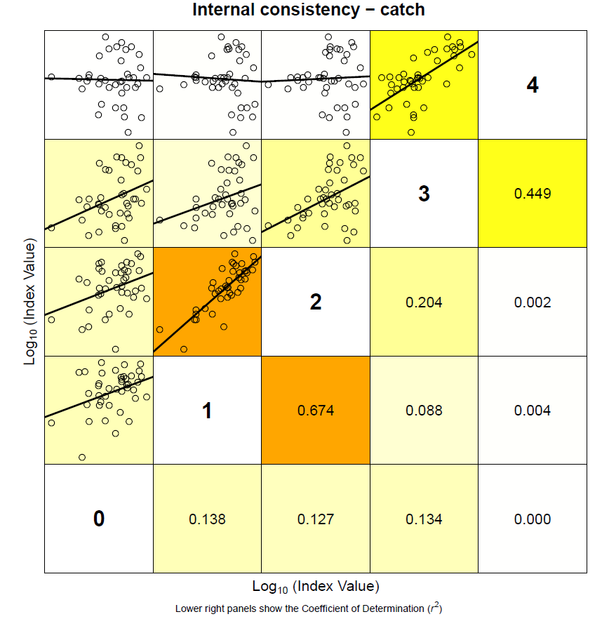

*Figure 6.1.3.1. Catch at age data (numbers at age) between-year consistency plot for GSA 17 West-East and GSA 18 West-East anchovy.*

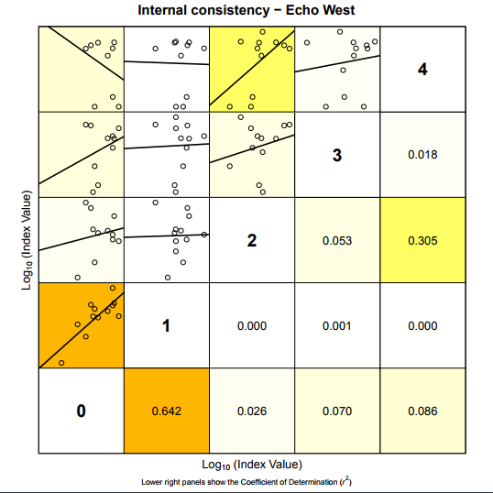

*Figure 6.1.3.2. MEDIAS acoustic survey index (numbers at age) between-year consistency plot for GSA 17 West and GSA 18 West-East anchovy.*

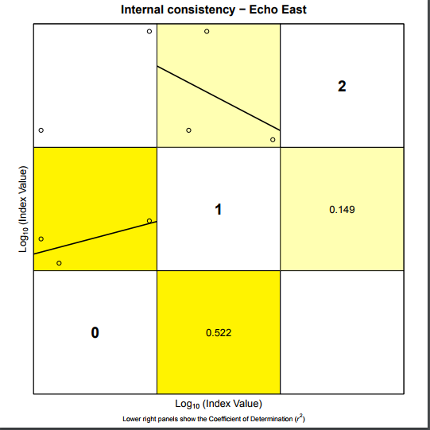

*Figure 6.1.3.3. MEDIAS acoustic survey index between-year consistency plot for GSA 17 East anchovy.*

### 6.1.4 Results

The average fishing mortality for ages 1-2 (presented in figure 6.1.4.1., middle) shows a constant increase from the beginning of the time series up to 2011, when reaches the value of 1.31. Afterwards a slight decrease to 2013 (Fbar1-2 = 1.08), the fishing mortality increased again reaching the maximum value of 1.43 in 2016.

The spawning stock biomass (figure 6.1.4.1., top) fluctuates from the highest values in the late seventies (about 284,930 tonnes) to a first drop in the 1987 with a biomass of 43,391 tonnes. After that the stock recovers and peaks again in 2005 with a biomass of 194,269 tonnes. From then on, it shows a descending trend. The estimates for 2015 and 2016 are respectively 78,433t and 57,469t.

The recruitment (age 0 – figure 6.1.4.1., bottom) follows the trend of the SSB, showing however less fluctuations. After a big peak in the seventies (202,044 thousands) and a drop in the late eighties (19,915 thousands), the recruitment shows a more or less constant increase reaching higher values between 2004 and 2009 (average ~ 108,455 thousands). It shows a mild but constant decrease afterwards. The current value (2016) is 45,764 thousands.

### *Table 6.1.4. Results of the final FLSAM assessment of anchovy in GSA17-18.*

|  |  |  |  |  |  |  |  |  |  |
| --- | --- | --- | --- | --- | --- | --- | --- | --- | --- |
| **Year** | **Recruits Age 0 (Thousands) Mean** | **Recruits Age 0 (Thousands) Low** | **Recruits Age 0 (Thousands) High** | **Total biomass (tonnes) Mean** | **Total biomass (tonnes) Low** | **Total biomass (tonnes) High** | | | |
| 1975 | 1.5E+08 | 97029693 | 2.32E+08 | 750879.2 | 510994.9 | 1103376 |  |  | |
| 1976 | 1.81E+08 | 1.21E+08 | 2.72E+08 | 1128049 | 772923.7 | 1646339 |  |  | |
| 1977 | 2.02E+08 | 1.36E+08 | 3E+08 | 1150837 | 797709.4 | 1660286 |  |  | |
| 1978 | 1.89E+08 | 1.29E+08 | 2.77E+08 | 1129177 | 801150.4 | 1591513 |  |  | |
| 1979 | 1.55E+08 | 1.07E+08 | 2.25E+08 | 989544.5 | 710971.2 | 1377269 |  |  | |
| 1980 | 1.2E+08 | 82814092 | 1.74E+08 | 764517.4 | 558969.8 | 1045650 |  |  | |
| 1981 | 94112365 | 64997151 | 1.36E+08 | 669977.9 | 483865.2 | 927676.5 |  |  | |
| 1982 | 74551446 | 51739621 | 1.07E+08 | 524919.4 | 383203.7 | 719044.1 |  |  | |
| 1983 | 57024981 | 39814113 | 81675775 | 410446.1 | 302124.1 | 557605.4 |  |  | |
| 1984 | 37958348 | 25946934 | 55530113 | 295079.5 | 215964.6 | 403176.6 |  |  | |
| 1985 | 24667570 | 16465687 | 36954974 | 173685.2 | 121536.1 | 248210.8 |  |  | |
| 1986 | 19915323 | 13416835 | 29561376 | 196811.2 | 139766 | 277139.1 |  |  | |
| 1987 | 22976902 | 15958759 | 33081395 | 196811.2 | 140728.1 | 275244.4 |  |  | |
| 1988 | 29650810 | 20970944 | 41923270 | 229349 | 167167.9 | 314659.4 |  |  | |
| 1989 | 35962957 | 25474212 | 50770336 | 279288.3 | 204427.4 | 381563.3 |  |  | |
| 1990 | 36215581 | 25721125 | 50991872 | 284930.3 | 210281 | 386080 |  |  | |
| 1991 | 34830361 | 24823278 | 48871629 | 239186.8 | 178781.6 | 320001.1 |  |  | |
| 1992 | 34346133 | 24523314 | 48103486 | 261450.4 | 195334.7 | 349944.7 |  |  | |
| 1993 | 44633712 | 32241893 | 61788190 | 299838.7 | 225084.8 | 399419.5 |  |  | |
| 1994 | 55008595 | 39962082 | 75720418 | 364397.3 | 275933.5 | 481222.4 |  |  | |
| 1995 | 56797337 | 41360331 | 77995930 | 497823.1 | 377463.2 | 656561.5 |  |  | |
| 1996 | 57886804 | 42187579 | 79428166 | 498321.1 | 378760.3 | 655623 |  |  | |
| 1997 | 58410136 | 42560638 | 80161956 | 461852.1 | 352986.8 | 604292.7 |  |  | |
| 1998 | 60551209 | 44369622 | 82634217 | 579545.8 | 440712.8 | 762113.8 |  |  | |
| 1999 | 66519121 | 48564356 | 91111957 | 587716.5 | 445457 | 775407.5 |  |  | |
| 2000 | 60611791 | 44161415 | 83190024 | 348711.4 | 268107.8 | 453547.6 |  |  | |
| 2001 | 57425557 | 42123823 | 78285738 | 383847.3 | 295093.2 | 499295.6 |  |  | |
| 2002 | 70069629 | 51737323 | 94897697 | 462314.2 | 354449.8 | 603003.3 |  |  | |
| 2003 | 91422301 | 68098844 | 1.23E+08 | 547435.5 | 421367.9 | 711220.9 |  |  | |
| 2004 | 1.14E+08 | 82022389 | 1.57E+08 | 751630.4 | 563708 | 1002200 |  |  | |
| 2005 | 1.17E+08 | 87072843 | 1.57E+08 | 876770 | 674107.2 | 1140361 |  |  | |
| 2006 | 1.09E+08 | 82825621 | 1.44E+08 | 818312.9 | 649498.1 | 1031005 |  |  | |
| 2007 | 97269886 | 72937626 | 1.3E+08 | 591253.4 | 469685 | 744287.3 |  |  | |
| 2008 | 1.07E+08 | 81387967 | 1.41E+08 | 653436.1 | 517588.8 | 824938.1 |  |  | |
| 2009 | 1.06E+08 | 80042988 | 1.41E+08 | 602594.6 | 475533.6 | 763606 |  |  | |
| 2010 | 91696980 | 69692272 | 1.21E+08 | 523870.6 | 417504.9 | 657334.6 |  |  | |
| 2011 | 83470180 | 63521793 | 1.1E+08 | 486017.5 | 387603.3 | 609419.7 |  |  | |
| 2012 | 87486933 | 66781162 | 1.15E+08 | 352216 | 282657.2 | 438892.6 |  |  | |
| 2013 | 63783175 | 47537033 | 85581560 | 358613.3 | 287588.1 | 447179.6 |  |  | |
| 2014 | 66652292 | 51899805 | 85598165 | 527023.3 | 419071.8 | 662782.7 |  |  | |
| 2015 | 51598337 | 39129421 | 68040577 | 372130.5 | 293146.8 | 472395.2 |  |  | |
| 2016 | 45763620 | 29144268 | 71860062 | 269682.3 | 187647.7 | 387580.3 |  |  | |
|  |  |  |  |  |  |  |  |  | |
| **Year** | **Spawing biomass (tonnes) Mean** | **Spawing biomass (tonnes) Low** | **Spawing biomass (tonnes) High** | **Landings (tonnes) Mean** | **Landings (tonnes) Low** | **Landings (tonnes) High** | | | |
| 1975 | 177371.2 | 122148.5 | 257559.9 | 21781.15 | 17094.38 | 27752.89 |  | |  |
| 1976 | 254485.7 | 175842.5 | 368301.1 | 30001.42 | 24647.52 | 36518.29 |  | |  |
| 1977 | 277895.4 | 192791 | 400567.7 | 37911.13 | 30799.08 | 46665.48 |  | |  |
| 1978 | 284930.3 | 203067.2 | 399795.2 | 47762.69 | 39116.34 | 58320.24 |  | |  |
| 1979 | 261712 | 187171.6 | 365937.9 | 51021.38 | 41917.19 | 62102.95 |  | |  |
| 1980 | 213416.3 | 154022.8 | 295712.8 | 52891.61 | 42379.58 | 66011.09 |  | |  |
| 1981 | 171785.2 | 124130.8 | 237734.4 | 36098.26 | 29513.13 | 44152.71 |  | |  |
| 1982 | 139246.4 | 100498.2 | 192934.3 | 35596.41 | 28707.38 | 44138.62 |  | |  |
| 1983 | 109316.2 | 79301.38 | 150691.4 | 28825.05 | 23212.8 | 35794.19 |  | |  |
| 1984 | 83616.82 | 59788.32 | 116942.1 | 27092.17 | 21596.08 | 33986.98 |  | |  |
| 1985 | 56954.05 | 34602.79 | 93742.82 | 31101.15 | 21282.12 | 45450.43 |  | |  |
| 1986 | 52627.81 | 35470.34 | 78084.59 | 18337.44 | 14202.52 | 23676.19 |  | |  |
| 1987 | 43390.68 | 31032.22 | 60670.86 | 7767.472 | 5938.078 | 10160.46 |  | |  |
| 1988 | 52417.72 | 38138.9 | 72042.39 | 10115.26 | 8388.163 | 12197.95 |  | |  |
| 1989 | 64601.96 | 47396.35 | 88053.48 | 12981.75 | 10724.92 | 15713.49 |  | |  |
| 1990 | 69633.43 | 51432.38 | 94275.52 | 14788.42 | 12127.47 | 18033.23 |  | |  |
| 1991 | 64860.88 | 47696.5 | 88202.17 | 17556.86 | 14456.27 | 21322.46 |  | |  |
| 1992 | 66702.65 | 49566.95 | 89762.31 | 16791.03 | 13856.81 | 20346.58 |  | |  |
| 1993 | 71539.14 | 53746.62 | 95221.78 | 16697.26 | 13740.18 | 20290.74 |  | |  |
| 1994 | 87903.95 | 66856.62 | 115577.2 | 20887.37 | 17149.16 | 25440.45 |  | |  |
| 1995 | 116774.5 | 89009.71 | 153199.9 | 30546.34 | 25007.79 | 37311.51 |  | |  |
| 1996 | 116891.3 | 89331.33 | 152954 | 32144.61 | 26583.2 | 38869.5 |  | |  |
| 1997 | 112420.3 | 86020.63 | 146922.1 | 34544.37 | 28417.67 | 41991.97 |  | |  |
| 1998 | 128540.6 | 98658.49 | 167473.5 | 34752.26 | 28619.86 | 42198.67 |  | |  |
| 1999 | 126121.4 | 97218.08 | 163617.7 | 31257.04 | 25208.32 | 38757.16 |  | |  |
| 2000 | 87378.1 | 66753.02 | 114375.8 | 33289.59 | 27009.57 | 41029.79 |  | |  |
| 2001 | 89232.45 | 68454.84 | 116316.5 | 32273.44 | 26194.35 | 39763.35 |  | |  |
| 2002 | 97635.85 | 75893.11 | 125607.7 | 27805.8 | 22524.94 | 34324.74 |  | |  |
| 2003 | 114233.5 | 89460.17 | 145867.1 | 28085.26 | 22237.7 | 35470.46 |  | |  |
| 2004 | 156060.7 | 120159.5 | 202688.3 | 37086.19 | 30229.45 | 45498.2 |  | |  |
| 2005 | 194269.2 | 150336.6 | 251040.1 | 50817.7 | 41278.74 | 62560.99 |  | |  |
| 2006 | 184979.4 | 148780.1 | 229986.4 | 61205.97 | 48869.74 | 76656.25 |  | |  |
| 2007 | 141209.5 | 113273.3 | 176035.5 | 59337.69 | 46052.29 | 76455.73 |  | |  |
| 2008 | 142059.3 | 113963.9 | 177081 | 51482.64 | 41752.52 | 63480.29 |  | |  |
| 2009 | 133252.4 | 106658 | 166477.7 | 48727.56 | 39254.13 | 60487.26 |  | |  |
| 2010 | 120090.4 | 95743.12 | 150629.1 | 51225.87 | 41232.78 | 63640.87 |  | |  |
| 2011 | 108988.8 | 87252.33 | 136140.2 | 44712.13 | 35733.88 | 55946.19 |  | |  |
| 2012 | 83199.78 | 66707.24 | 103769.9 | 37123.3 | 29490.91 | 46730.99 |  | |  |
| 2013 | 87816.09 | 71153.44 | 108380.8 | 36026.14 | 27512.67 | 47173.99 |  | |  |
| 2014 | 101925.8 | 81230.95 | 127892.9 | 32958.35 | 26659.18 | 40745.93 |  | |  |
| 2015 | 78433 | 62285.53 | 98766.68 | 34132.32 | 26117.02 | 44607.51 |  | |  |
| 2016 | 57468.95 | 41743.72 | 79117.99 | 28652.62 | 22220.02 | 36947.42 |  | |  |
|  |  |  |  |  |  |  |  | |  |
| **Year** | **Yield / SSB (ratio) Mean** | **Yield / SSB (ratio) Low** | **Yield / SSB (ratio) High** | **Mean F ages 2-6 Mean** | **Mean F ages 2-6 Low** | **Mean F ages 2-6 High** | **Mean F ages 0-1** | | **SoP (%)** |
| 1975 | 0.1228 | 0.139948 | 0.107753 | 0.231911 | 0.149427 | 0.359928 | 0.067286 | | 1 |
| 1976 | 0.11789 | 0.140168 | 0.099153 | 0.226457 | 0.151407 | 0.338708 | 0.066101 | | 1 |
| 1977 | 0.136422 | 0.159754 | 0.116498 | 0.221818 | 0.151653 | 0.324445 | 0.067671 | | 1 |
| 1978 | 0.167629 | 0.192628 | 0.145875 | 0.242101 | 0.16941 | 0.345983 | 0.071718 | | 1 |
| 1979 | 0.194952 | 0.223951 | 0.169709 | 0.248031 | 0.175046 | 0.351448 | 0.073359 | | 1 |
| 1980 | 0.247833 | 0.275151 | 0.223227 | 0.264848 | 0.187791 | 0.373523 | 0.075608 | | 1 |
| 1981 | 0.210136 | 0.237758 | 0.185723 | 0.261584 | 0.186692 | 0.366519 | 0.076242 | | 1 |
| 1982 | 0.255636 | 0.285651 | 0.228775 | 0.265856 | 0.190669 | 0.370692 | 0.077883 | | 1 |
| 1983 | 0.263685 | 0.292716 | 0.237533 | 0.270468 | 0.194995 | 0.375155 | 0.081673 | | 1 |
| 1984 | 0.324004 | 0.361209 | 0.290631 | 0.298317 | 0.215773 | 0.412437 | 0.093412 | | 1 |
| 1985 | 0.546074 | 0.61504 | 0.484842 | 0.342049 | 0.239096 | 0.489335 | 0.109702 | | 1 |
| 1986 | 0.348436 | 0.400406 | 0.303212 | 0.298585 | 0.20828 | 0.428044 | 0.09857 | | 1 |
| 1987 | 0.179012 | 0.191352 | 0.167469 | 0.266762 | 0.182141 | 0.390695 | 0.088974 | | 1 |
| 1988 | 0.192974 | 0.219937 | 0.169316 | 0.301526 | 0.211688 | 0.429489 | 0.10221 | | 1 |
| 1989 | 0.20095 | 0.226282 | 0.178454 | 0.331774 | 0.235218 | 0.467966 | 0.109305 | | 1 |
| 1990 | 0.212375 | 0.235794 | 0.191282 | 0.344314 | 0.245601 | 0.482702 | 0.115839 | | 1 |
| 1991 | 0.270685 | 0.303089 | 0.241745 | 0.37039 | 0.264875 | 0.517936 | 0.121337 | | 1 |
| 1992 | 0.25173 | 0.279557 | 0.226672 | 0.372484 | 0.267892 | 0.517914 | 0.11455 | | 1 |
| 1993 | 0.2334 | 0.255647 | 0.213089 | 0.383736 | 0.278734 | 0.528293 | 0.115975 | | 1 |
| 1994 | 0.237616 | 0.256507 | 0.220116 | 0.40773 | 0.300672 | 0.552907 | 0.128179 | | 1 |
| 1995 | 0.261584 | 0.280956 | 0.243548 | 0.453169 | 0.3366 | 0.610108 | 0.140696 | | 1 |
| 1996 | 0.274996 | 0.29758 | 0.254125 | 0.475371 | 0.354359 | 0.637707 | 0.143639 | | 1 |
| 1997 | 0.307279 | 0.330359 | 0.285811 | 0.515917 | 0.385195 | 0.691002 | 0.154417 | | 1 |
| 1998 | 0.27036 | 0.29009 | 0.251972 | 0.537272 | 0.402762 | 0.716705 | 0.155986 | | 1 |
| 1999 | 0.247833 | 0.259297 | 0.236876 | 0.543933 | 0.410851 | 0.720121 | 0.165673 | | 1 |
| 2000 | 0.380983 | 0.404619 | 0.358728 | 0.620245 | 0.468053 | 0.821925 | 0.185247 | | 1 |
| 2001 | 0.361678 | 0.382652 | 0.341855 | 0.687331 | 0.512492 | 0.921815 | 0.192978 | | 1 |
| 2002 | 0.284791 | 0.296798 | 0.273269 | 0.718026 | 0.536851 | 0.960343 | 0.187018 | | 1 |
| 2003 | 0.245858 | 0.248577 | 0.24317 | 0.693732 | 0.530802 | 0.906673 | 0.178579 | | 1 |
| 2004 | 0.23764 | 0.251578 | 0.224474 | 0.672153 | 0.521262 | 0.866721 | 0.158663 | | 1 |
| 2005 | 0.261584 | 0.274575 | 0.249207 | 0.642178 | 0.496273 | 0.83098 | 0.145314 | | 1 |
| 2006 | 0.33088 | 0.32847 | 0.333308 | 0.64821 | 0.498154 | 0.843468 | 0.124155 | | 1 |
| 2007 | 0.42021 | 0.406559 | 0.43432 | 0.731323 | 0.568742 | 0.94038 | 0.119217 | | 1 |
| 2008 | 0.362402 | 0.366366 | 0.358482 | 0.857203 | 0.670819 | 1.095375 | 0.124319 | | 1 |
| 2009 | 0.365679 | 0.368037 | 0.363335 | 0.977913 | 0.776264 | 1.231943 | 0.156036 | | 1 |
| 2010 | 0.426561 | 0.430661 | 0.4225 | 1.146885 | 0.912181 | 1.44198 | 0.176401 | | 1 |
| 2011 | 0.410245 | 0.409546 | 0.410945 | 1.309545 | 1.016445 | 1.687164 | 0.183364 | | 1 |
| 2012 | 0.446195 | 0.442095 | 0.450333 | 1.245105 | 0.99657 | 1.555623 | 0.180949 | | 1 |
| 2013 | 0.410245 | 0.386667 | 0.435262 | 1.079418 | 0.855429 | 1.362056 | 0.173128 | | 1 |
| 2014 | 0.323356 | 0.32819 | 0.318594 | 1.186182 | 0.956787 | 1.470576 | 0.193545 | | 1 |
| 2015 | 0.435178 | 0.419311 | 0.451645 | 1.419678 | 1.115203 | 1.807281 | 0.218264 | | 1 |
| 2016 | 0.498576 | 0.532296 | 0.466991 | 1.42955 | 0.994247 | 2.055438 | 0.24345 | | 1 |

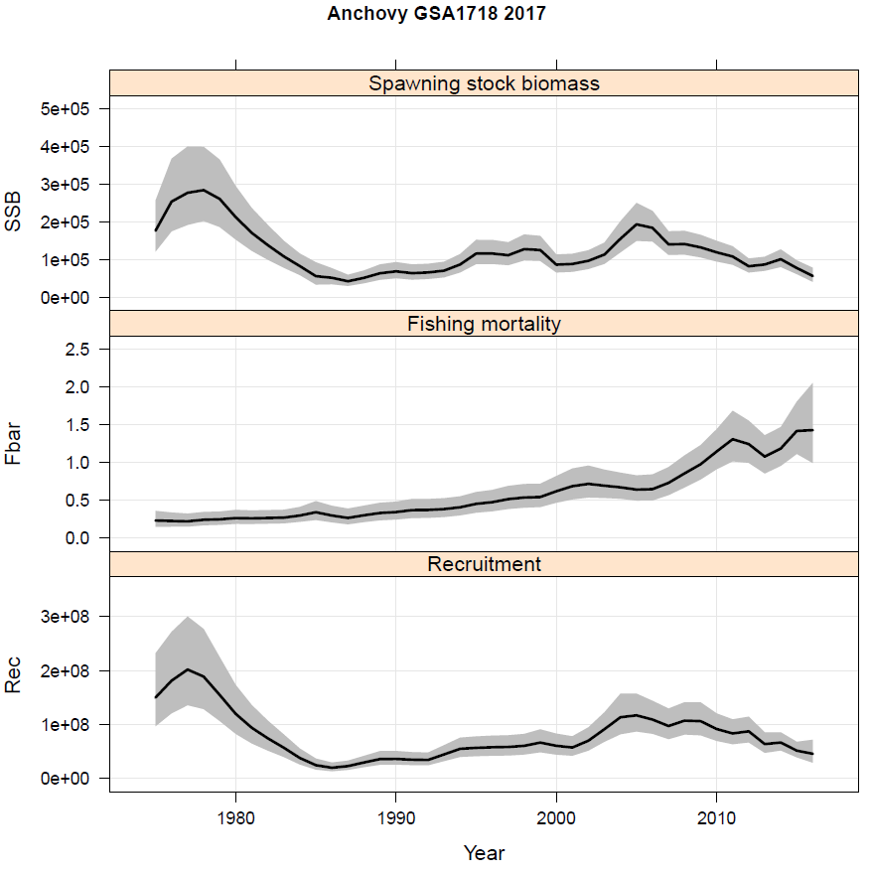

*Figure 6.1.4.1. Anchovy results from SAM model: SSB, F and recruitment estimates.*

### *Robustness analysis*

### Retrospective analysis, comparison between model runs, sensitivity analysis, etc.

Due to the very short time series of the tuning indexes (2013-2016 for the Echosurvey East), the retrospective analysis was run on 1 year only. The outputs are shown in Figure 8.1. and describe a rather consistent behavior of the assessment model, with the only exception of the slight variability and uncertainty in F estimate in the last year.

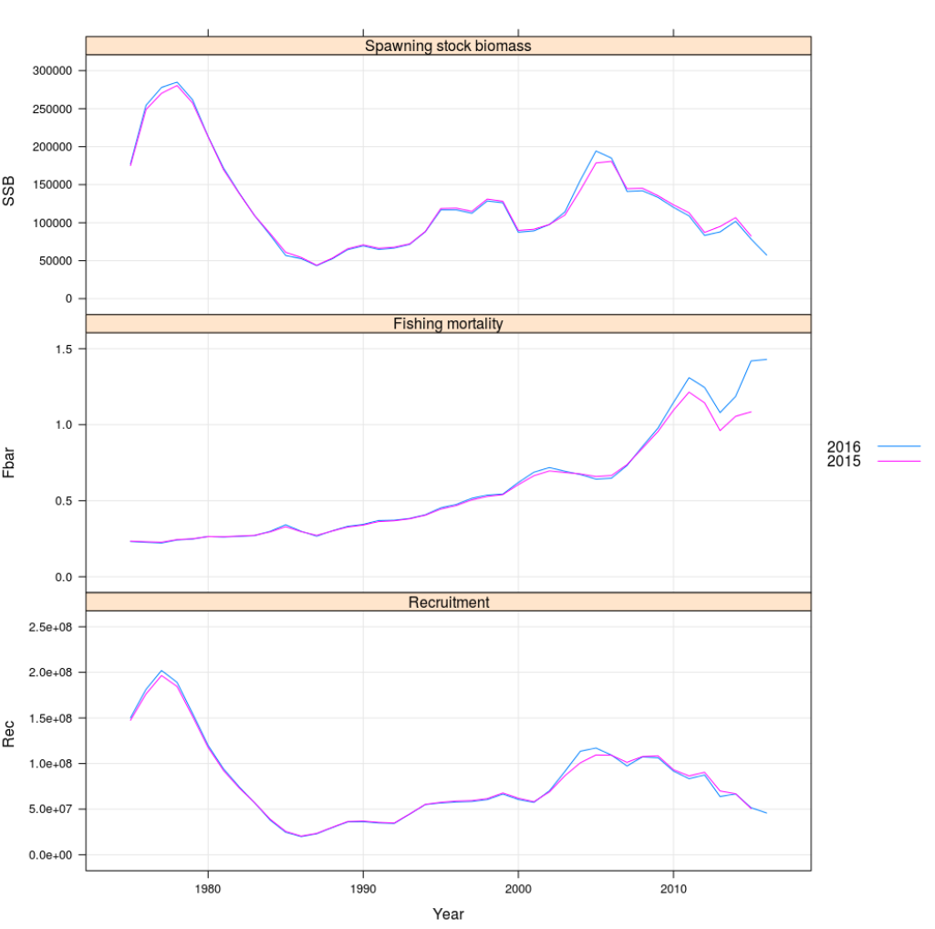

*Figure 8.1. FLSAM retrospective patterns for currently accepted assessment.*

The weight given to the input data is shown in the plot below: a higher weight is given to the Echo East age 1, followed by the catch at age data, similar weight is given to the western acoustic survey at age 0 and the eastern echosurvey age 1. The highest observation variance is accounted for the age data 2, 3 and 4 from the acoustic survey East and West.

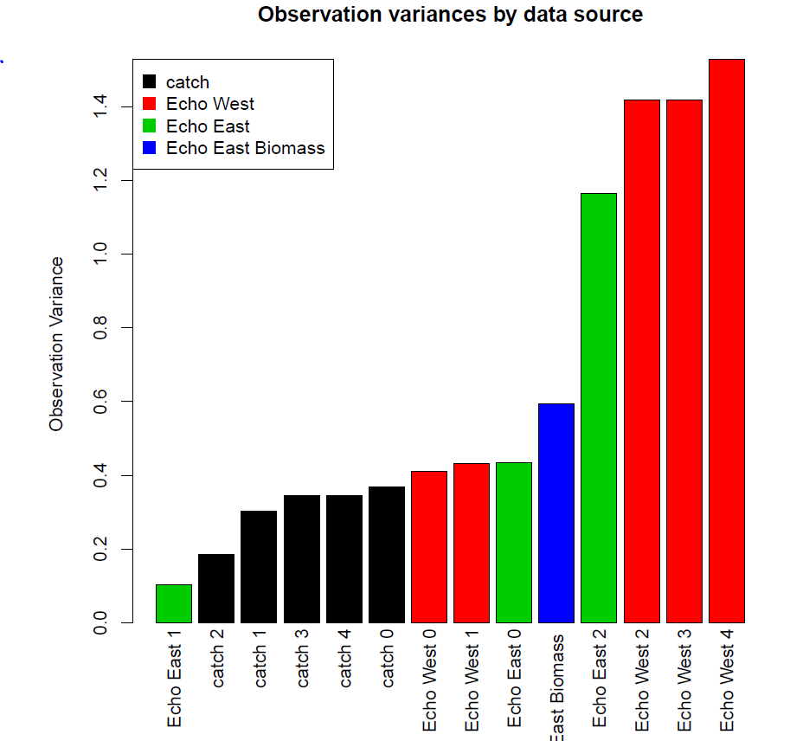

*Figure 8.2 Observation variances by data source of anchovy in GSA17-18.*

### *Assessment quality*

This assessment was performed using the updated data set from the last GFCM stock assessment (GFCM, 2017). However, some modifications were carried out:

1. Albania sent new catch for years from 2008 to 2016, thus landings and catch at age data for these years were updated with the new estimates;
2. Abundance indexes at age for acoustic survey West (since 2004) and East (since 2013) were updated applying new age length keys, that are different from ALKs used for ageing recent commercial catches and age slicing of historical length data. These discrepancies can result in uncertainties and affect accuracy of catch-at-age matrix.

Figures 9.1, 9.2 and 9.3 show the different ALKs used in this year assessment. The most important differences are between the transition from age 0 to age 1.

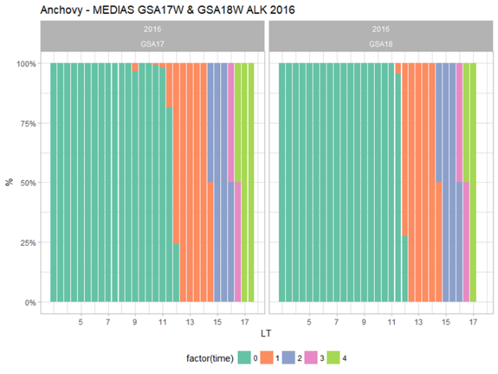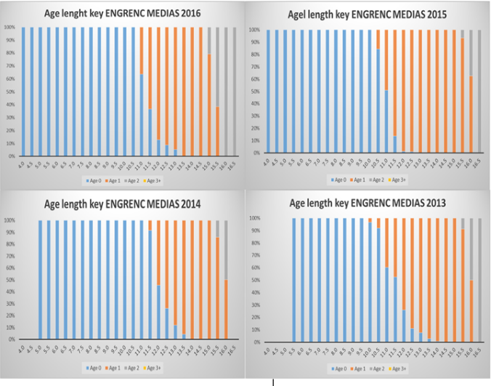

*Figure 9.1 - Anchovy GSA 17-18: age length key derived from otolith readings from MEDIAS surveys: surveys in western part of GSA 17 and GSA 18 in 2016 (left side), surveys in eastern part of GSA 17 in 2013-2016 (right side) applied to convert survey abundance at length to abundance at age.*

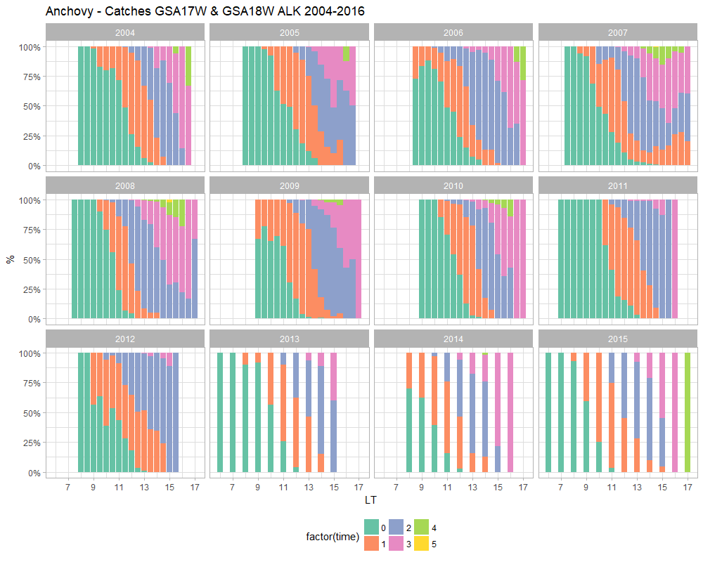

*Figure 9.2 - Anchovy GSA 17-18: age length key derived from otolith readings from Catch data from Italian catches 2004 to 2015 applied to length frequency data to convert catch at length to catch at age.*

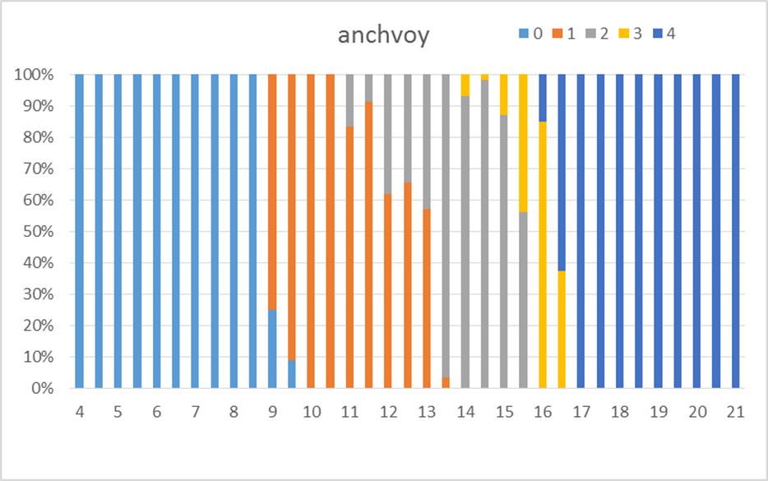

*Figure 9.3 - Anchovy GSA 17-18: age length key derived from otolith readings from Croatian catches applied to length frequency data to convert catch at length to catch at age.*

1. In agreement with the data availability from the previous Croatian national PELMON acoustic survey and their validity, the biomass estimates for years from 2003 to 2012 for the East Echosurvey in GSA17 were used as a third separate tuning index.
2. SOP corrections. Number at age catch data were adjusted with the SOP correction for the runs carried out in the EWG 17-09. Figure 9.4 shows the difference between the two data series.

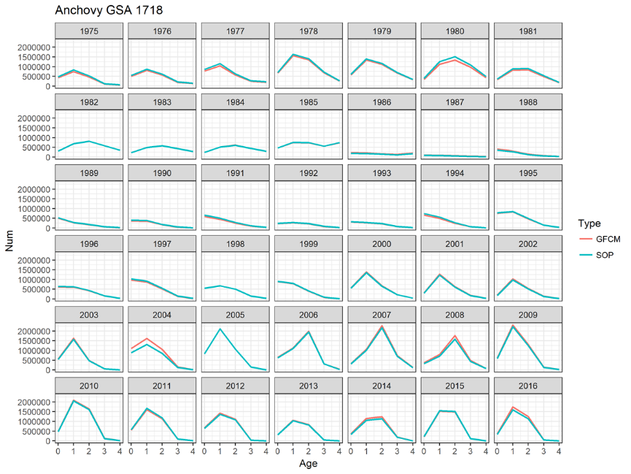

*Figure 9.4 - Anchovy GSA 17-18: differences between the catch at age numbers obtained by the ALK (red line – GFCM) and the catch at age numbers obtained by the ALK and the SOP correction (blue line – SOP).*

1. About the reference points, some criticism was expressed in the use of the EqSim routine, thus this year it was decided to use the Patterson’s criterion (E=F/Z=0.4) as precautionary fishing mortality reference point, whereas Blim and Bpa were estimated by empirical approach and assumed equal to the last year assessment.

All the modifications applied during this year assessment, basically do not produce relevant differences compared to the 2015 assessment. The reason of this is because the most important difference is given by the use of different ALKs from acoustic surveys, that is not particularly underlined by the results of the SAM model because the weight for the echosurvey data is quite low. However, the use of different ALKs is not recommended, thus it is suggested to find an agreement among all the readers in order to avoid discrepancies in the stock assessment procedure and obtain a more robust evaluation. In the previous assessment, not accurate estimates of abundance at age for the East echo survey were used, thus in the present assessment these were substituted by more accurate data, that is the total biomass for the years from 2003 to 2012.

The stock assessment of anchovy in GSA 17 and 18 was prepared during the STECF EWG 17-09. It is important to mention that the same dataset was used for the two assessments. However, during the STECF it was agreed to use a maturity 0 for age group 0 in order to have a better estimates of the spawning stock biomass, since age 0 individuals usually do not contribute to their own spawning.

During the GFCM WG, the point about the maturity at age of anchovy was discussed a lot. During the discussion it was underlined that this point is strictly correlated with the definition of the birthday used in ALK. At the present the stock assessment of anchovy is based on a calendar year, but the age reading (ALK) is derived considering the 1st of June as birth date; in this case, there will be a lot of age 0 in each year and some of them are mature, thus the value of 0.5 is reasonable. A proportion of 0 mature individuals for age 0, it is acceptable only if the ALK will consider the date of the 1st January as the birth date for anchovy because in this case the mature individuals of age 0 will be really few.

Considering this, the revision the aging procedure becomes an urgent point, that have to consider the fact that the stock assessment is based on a calendar year and thus the respective ALK has to combine the biological birth date (1st of June) with the calendar year.

Figure 9.5 summarizes all the runs carried out during the WGSASP. The results of the different assessments are really similar, except for the ANE_EWG_1709 run. This run represents the stock assessment accepted at the STECF EWG 17-09 including the value of 0 as a proportion of mature individuals for the age class 0, this implicates an underestimation of the spawning stock biomass. About the fishing mortality the trend is quite similar, all the runs underline a decreasing trend: the STECF EWG runs show a higher mortality probably due to the effect of a smaller SSB, whereas the differences between the GFCM runs can be explained by the changes included in this year assessment (see the beginning of this paragraph). However, the outcome of the different runs reveal that the stock is overexploited and in overexploitation.

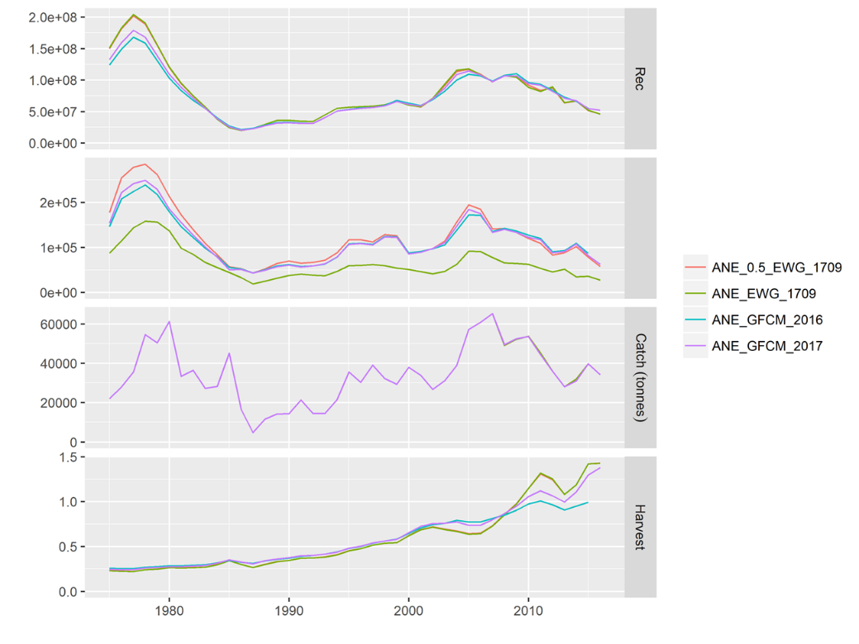

*Figure 9.5 – Comparisons of all the runs carried out during the WGSASP: green line represents the run accepted at STECF EWG 1709 (ANE_EWG_1709), the red line is the ANE_EWG_1709 run but including 0.5 as a proportion of mature individuals for age class 0, the blue line shows the results of the last year assessment (ANE_GFCM_2016) and the purple line represents the stock assessment accepted this year (ANE_GFCM_2017).*

# Stock Simulations

## Short term predictions

N/A

## Medium term predictions

## Long term predictions

# 14. Draft scientific advice

**(Examples in blue)**

|  |  |  |  |  |  |  |
| --- | --- | --- | --- | --- | --- | --- |
| **Based on** | **Indicator** | **Analytical reference point**  **(name and value)** | **Current value from the analysis**  **(name and value)** | **Empirical reference value**  **(name and value)** | **Trend**  **(time period)** | **Status** |
| **Fishing mortality** | Fishing mortality | Fmsy= 0.64 | Fcur = 1.43 |  | I | IOH |
|  | Fishing effort |  |  |  |  |  |
|  | Catch |  |  |  | D |  |
|  |  |  |  |  |  |  |
| **Stock abundance** | Biomass |  |  |  |  |  |
|  | SSB | Blim=45936  Bpa=91872 | Bcur= 57,469 |  |  | OL |
| **Recruitment** |  |  |  |  | D |  |
| **Final Diagnosis** | | Overexploited and in overexploitation. | | | | |

Fcurrent is above FMSY and Bcurrent is close to Blim. Therefore, the stock is to be considered in overexploitation and overexploited.

## Explanation of codes

**Trend categories**

1. N - No trend
2. I - Increasing
3. D – Decreasing
4. C - Cyclic

**Stock Status**

**Based on Fishing mortality related indicators**

1. **N - Not known or uncertain** – Not much information is available to make a judgment;
2. **U - undeveloped or new fishery** - Believed to have a significant potential for expansion in total production;
3. **S - Sustainable exploitation**- fishing mortality or effort below an agreed fishing mortality or effort based Reference Point;
4. **IO –In Overfishing status**– fishing mortality or effort above the value of the agreed fishing mortality or effort based Reference Point. An agreed range of overfishing levels is provided;

**Range of Overfishing levels based on fishery reference points**

In order to assess the level of overfishing status when F0.1 from a Y/R model is used as LRP, the following operational approach is proposed:

* If Fc*/F0.1 is below or equal to 1.33 the stock is in **(OL): Low overfishing**
* If the Fc/F0.1 is between 1.33 and 1.66 the stock is in **(OI): Intermediate overfishing**
* If the Fc/F0.1 is equal or above to 1.66 the stock is in **(OH): High overfishing**

*Fc is current level of F

1. **C- Collapsed**- no or very few catches;

**Based on Stock related indicators**

1. **N - Not known or uncertain:** Not much information is available to make a judgment
2. **S - Sustainably exploited:** Standing stock above an agreed biomass based Reference Point;
3. **O - Overexploited**: Standing stock below the value of the agreed biomass based Reference Point. An agreed range of overexploited status is provided;

**Empirical Reference framework for the relative level of stock biomass index**

* **Relative low biomass:** Values lower than or equal to 33rd percentile of biomass index in the time series **(OL)**
* **Relative intermediate biomass:** Values falling within this limit and 66th percentile **(OI)**
* **Relative high biomass:** Values higher than the 66th percentile **(OH)**

1. **D – Depleted**: Standing stock is at lowest historical levels, irrespective of the amount of fishing effort exerted;
2. **R –Recovering:** Biomass are increasing after having been depleted from a previous period;

***Agreed definitions as per SAC Glossary***

***Overfished (or overexploited)*** - *A stock is considered to be overfished when its abundance is below an agreed biomass based reference target point, like B0.1 or BMSY. To apply this denomination, it should be assumed that the current state of the stock (in biomass) arises from the application of excessive fishing pressure in previous years. This classification is independent of the current level of fishing mortality.*

***Stock subjected to overfishing (or overexploitation)*** *- A stock is subjected to overfishing if the fishing mortality applied to it exceeds the one it can sustainably stand, for a longer period. In other words, the current fishing mortality exceeds the fishing mortality that, if applied during a long period, under stable conditions, would lead the stock abundance to the reference point of the target abundance (either in terms of biomass or numbers).*